Name

L

Date Pd

Unit 1 – Activity 6:

Computationally modeling Change over time

For this activity you will need an internet-capable computer. Open a browser window and navigate to the following URL:

[https://code.pyret.org/editor#share=1VDRm6trOpJXKFKcxTbhyNE6fgj7Uqk07&v=f9e4ffe](https://code.pyret.org/editor" \l "share=1VDRm6trOpJXKFKcxTbhyNE6fgj7Uqk07&v=f9e4ffe)

You will see a screen that looks something like this with some information entered on the left-hand window.

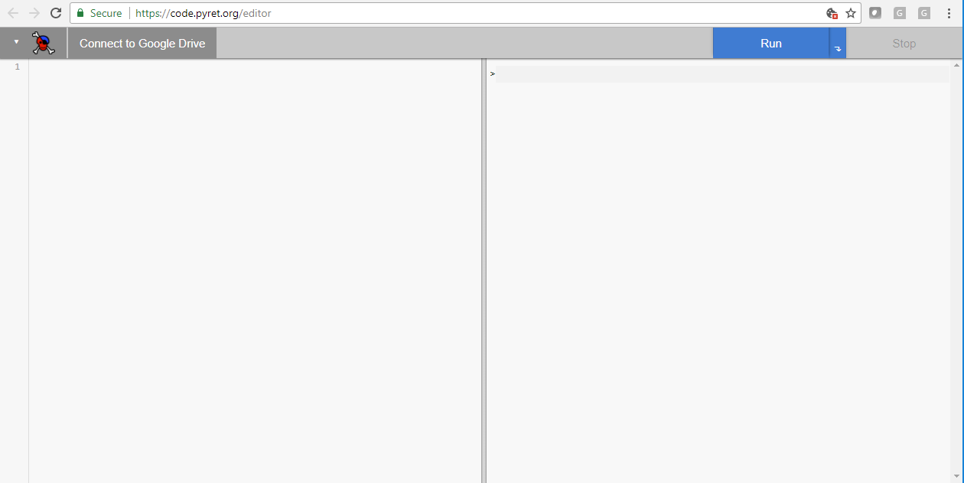

Click the “run” button.

1. What did you observe?
2. Close the simulation window by clicking the “X” in the upper lefthand corner and examine the screen. What types of information do you see on the lefthand side of the screen?
3. Under the heading “Constant Values” you will see two values: *initial-height* and *internal-energy-transferred.* These represent the height of the basketball in centimeters before it begins to fall and the amount of energy transferred to the “internal energy” storage account each time the ball bounces. Make a note of these preset values—you will need to return to them later.

Initial-height ________________

Internal-energy-transferred *________________*

1. If you were to change the value of *internal-energy-transferred* to a larger number, what would you expect to change in the simulation?
2. Try it. Then click “run” again. How was the simulation different from before?
3. What would you expect to happen if you made the *internal-energy-transferred* significantly lower than it was originally?
4. Try it and describe what happens.
5. Return the *internal-energy-transferred* to its initial value. Now predict what will happen if you increase the *intial-height* value?
6. Try it and describe what happens.
7. Return the constants to their preset values (you recorded these in question 3). Click “Run.” In the window on the right side of the screen you may have noticed an output value each time you run the simulation. What do you think this value represents?
8. In the righthand window type the following [what is the command to display a table?]. What do the values in the righthand column of the table represent?
9. What do the values in the lefthand column represent?
10. Scroll to the bottom of the table. It’s quite long. If you were to increase the *internal-energy-transferred* value do you think this would affect the length of the table? If so, how?
11. Try it. What happened?
12. Predict how the length of the table would change if you increased the *initial-height* of the ball. Justify your prediction.